**New York City Bike Analysis**

<https://public.tableau.com/profile/bhavini5231#!/vizhome/City_Bike_Analysis_15766020308630/CityBikeAnalysis?publish=yes>

* How many trips have been recorded total during the chosen period?

**2017:** 266,129

**2018:** 339,687

* By what percentage has total ridership grown?

**27.**64% ridership growth from 2017 to 2018.

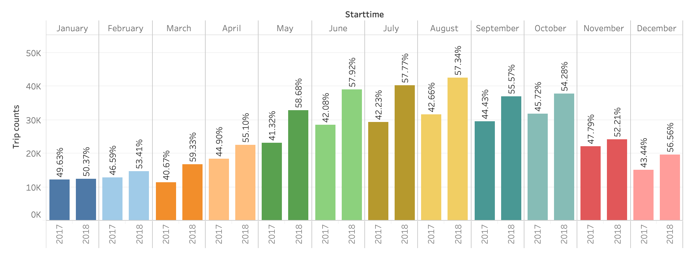

* How has the proportion of short-term customers and annual subscribers changed?

Subscribers are higher in number than customers (short term).

Total riders increase during summer month, but it is interesting to see that rate of customers also increases. May be due to summer, travelers used the bikes for short distances.

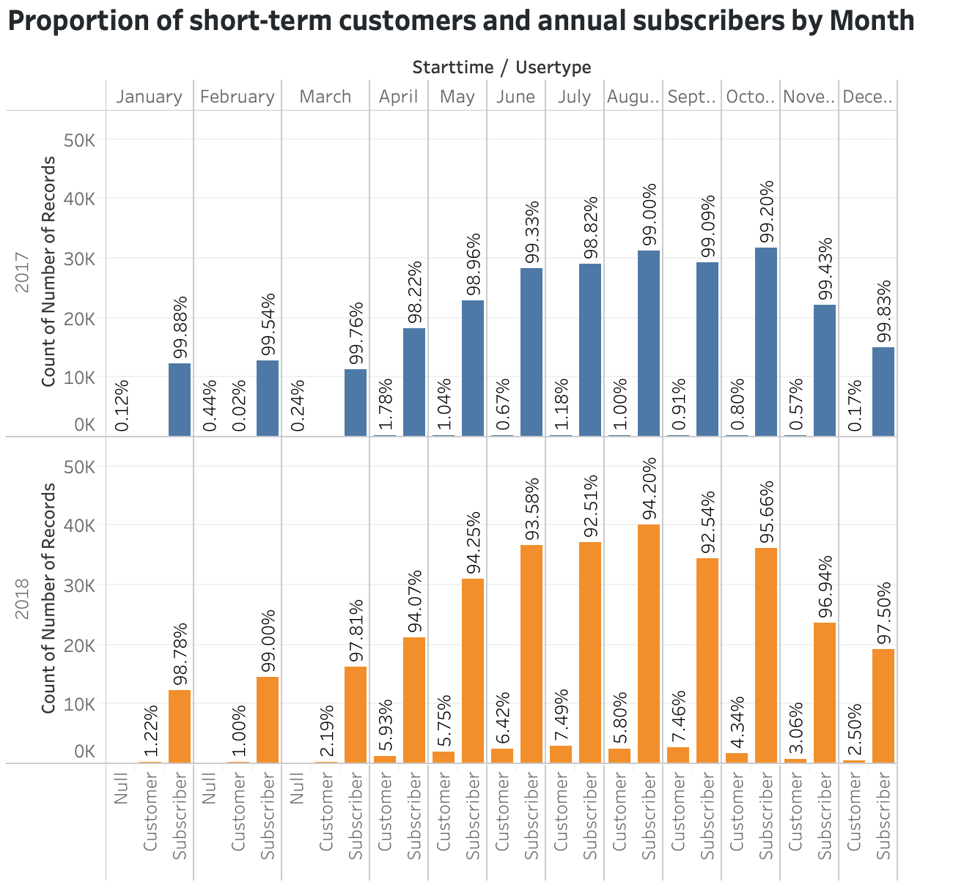

* What are the peak hours in which bikes are used during summer months?

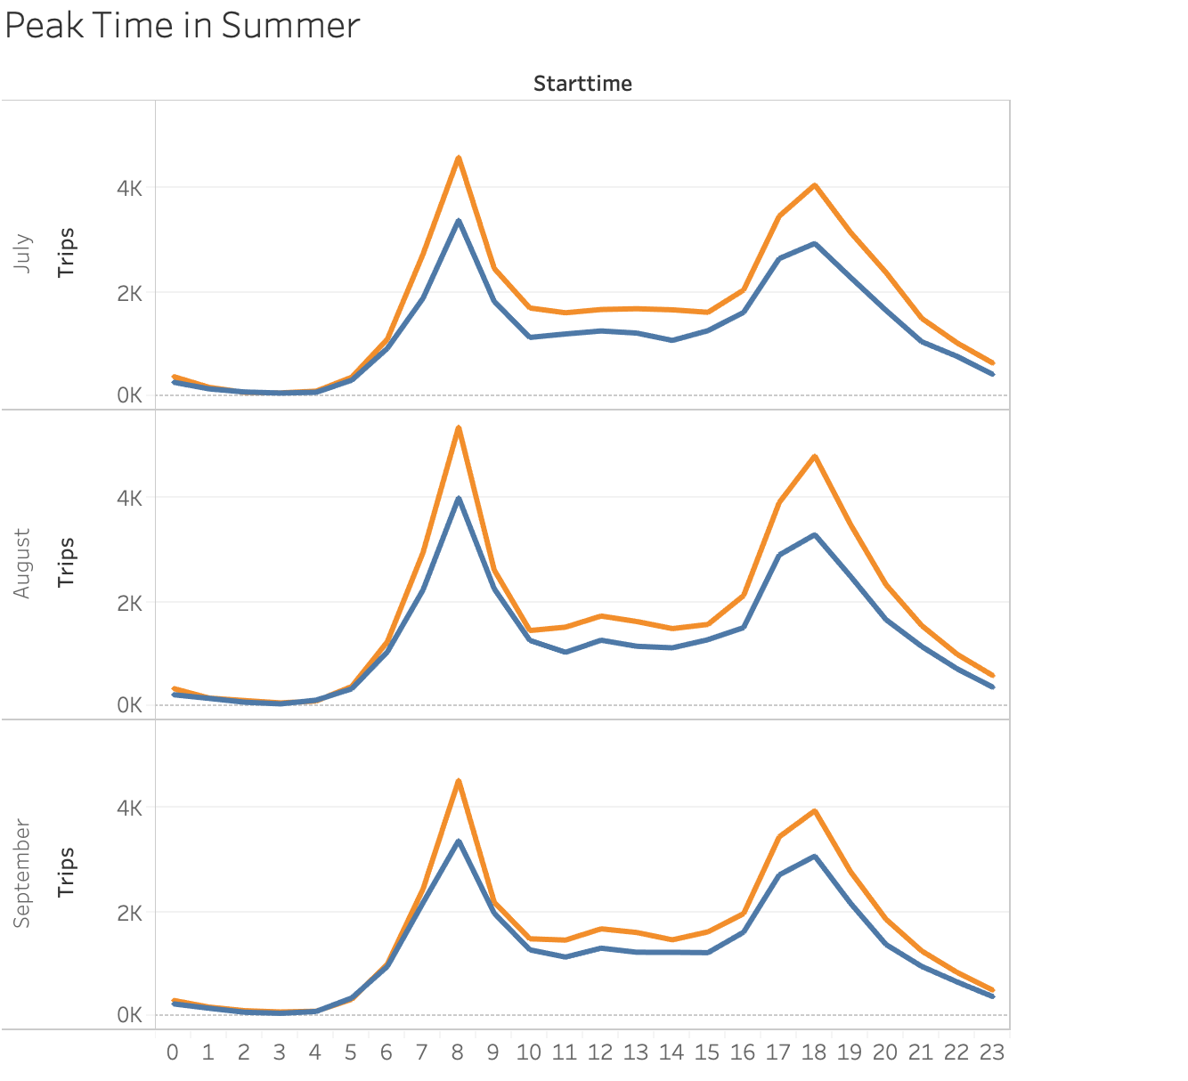

* What are the peak hours in which bikes are used during winter months?

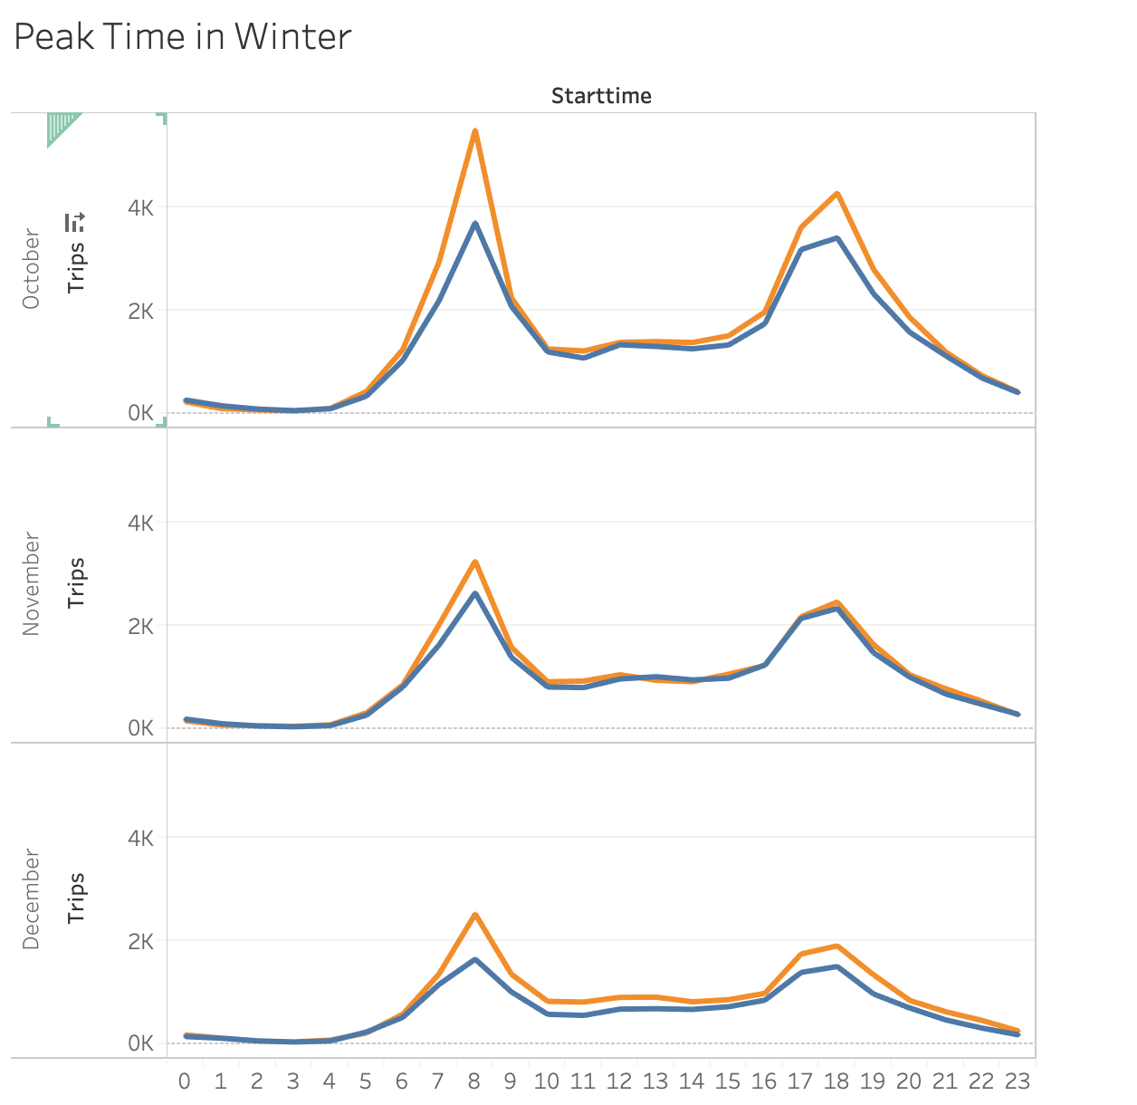

During Summer and Winter, Bike usage is mostly between 7-9am and 6-8pm.

* Today, what are the top 10 stations in the city for starting a journey? (Based on data, why do you hypothesize these are the top locations?)
* Today, what are the top 10 stations in the city for ending a journey? (Based on data, why?)
* Today, what are the bottom 10 stations in the city for starting a journey? (Based on data, why?)
* Today, what are the bottom 10 stations in the city for ending a journey (Based on data, why?)

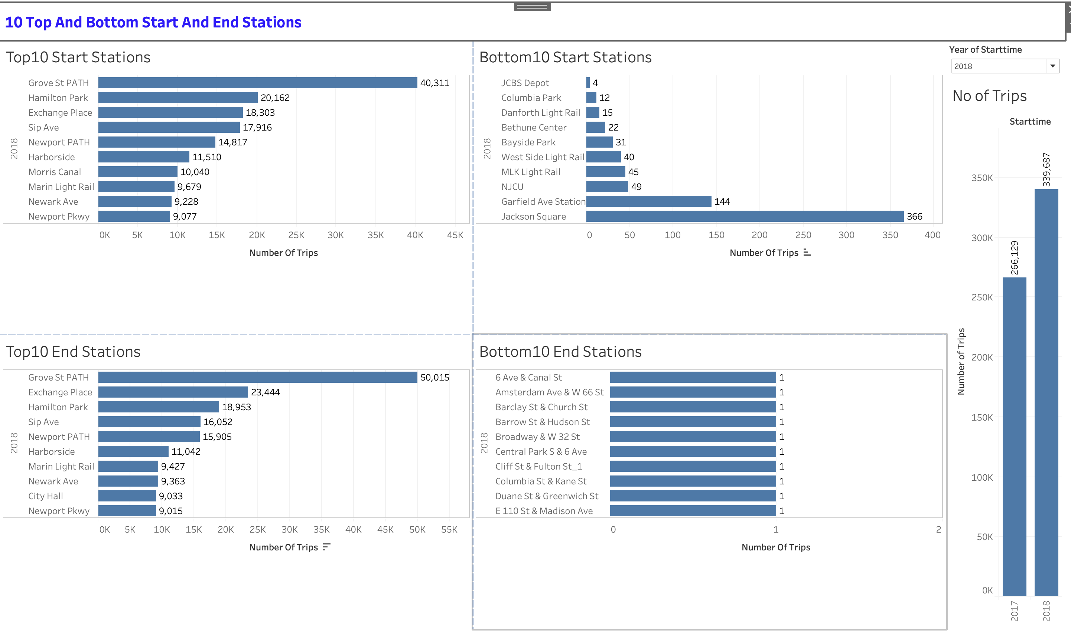

* Today, what is the gender breakdown of active participants (Male v. Female)?
* How effective has gender outreach been in increasing female ridership over the timespan?
* How does the average trip duration change by age?

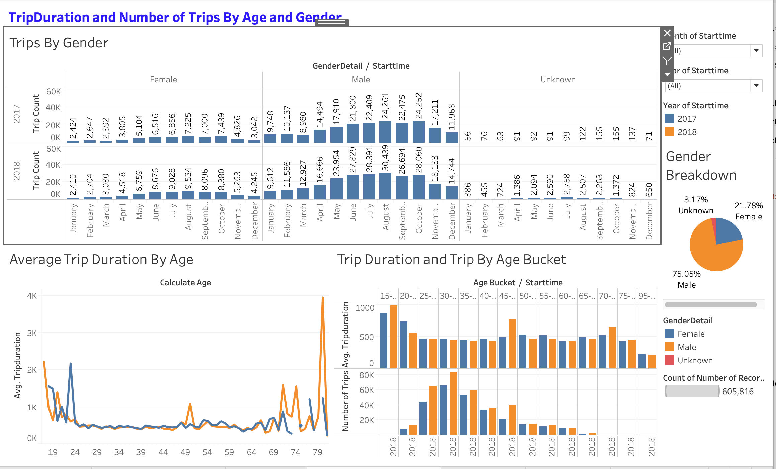

Map